

Case Study Workshop

Winchester House

Learning Objective

To understand the problem that we as Enterprise architects must fix

Introduction

**This learning by example scenario was first introduced in the first book on enterprise architecture which was titled Enterprise Architecture Planning by Spewak and Hill. It was first published in 1997 and for 10 years was the only useful book on the subject.**

**The book is still a rich source of techniques and good practices and is still in print.**

**It can be ordered through most on-line bookstores such as Amazon and Barnes and Noble.**

**Spewak and Hill drew some parallels with Winchester House and IT. This course goes further than this.**

The Winchester House

**In the lower Bay Area of sunny California, on the border between San Jose and Cupertino off Interstate Highway 280, there stands an enormous mansion known as Winchester House. It was built around the turn of the century by Sarah Winchester, who inherited a large fortune from her husband’s rifle company.**

**As she got on in age, Mrs. Winchester became increasingly eccentric. It seems that she was haunted by the ghosts of unfortunate people killed by rifles made by her husband. Two full-time spiritual advisors were employed on her staff who told her that she would continue to live as long as she continued to build.**

**Thus construction on this mansion continued 24 hours a day, seven days a week, month after month, year after year – for 38 years. The grounds are beautiful and custom-made stained glass, porcelain fixtures, and woodwork remarkable. But over the years Mrs Winchester added new wing here, a tower there. She designed each room individually with no thought to what existed or how the rooms would connect. Some rooms were remodelled more than a dozen times. There are more passageways than rooms. Vast sums of money were spent on the house.**

**However, the house is are such odd features as stairways that rise into ceilings doors and windows blocked by walls, a three-story chimney that falls short of the roof, and many rooms serving the same purpose.**

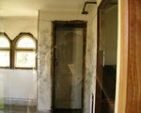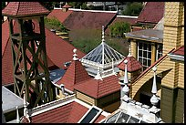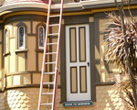

Tasks

**The team should prepare answers to the following questions.**

**Q1: Are there any parallels you can see between The Winchester House and IT in many companies?**

**Q2: Are there any similarities between The Winchester House and the structure and organisation of most businesses?**

**Q3: What could Mrs Winchester have done to avoid building such a chaotic house?**